Experiment No.: 8
Title: Access and validate form fields using events; design a gym admission form with live input checks.
Software/Tools Required: HTML5, CSS3, JavaScript, VS Code, Google Chrome
Theory: JavaScript provides DOM methods like getElementById() and querySelector() to access form fields. Event handlers such as input, change, and submit detect user actions, while validation conditions check whether the entered data is correct. Live validation gives immediate feedback without requiring page reloads..

Output:
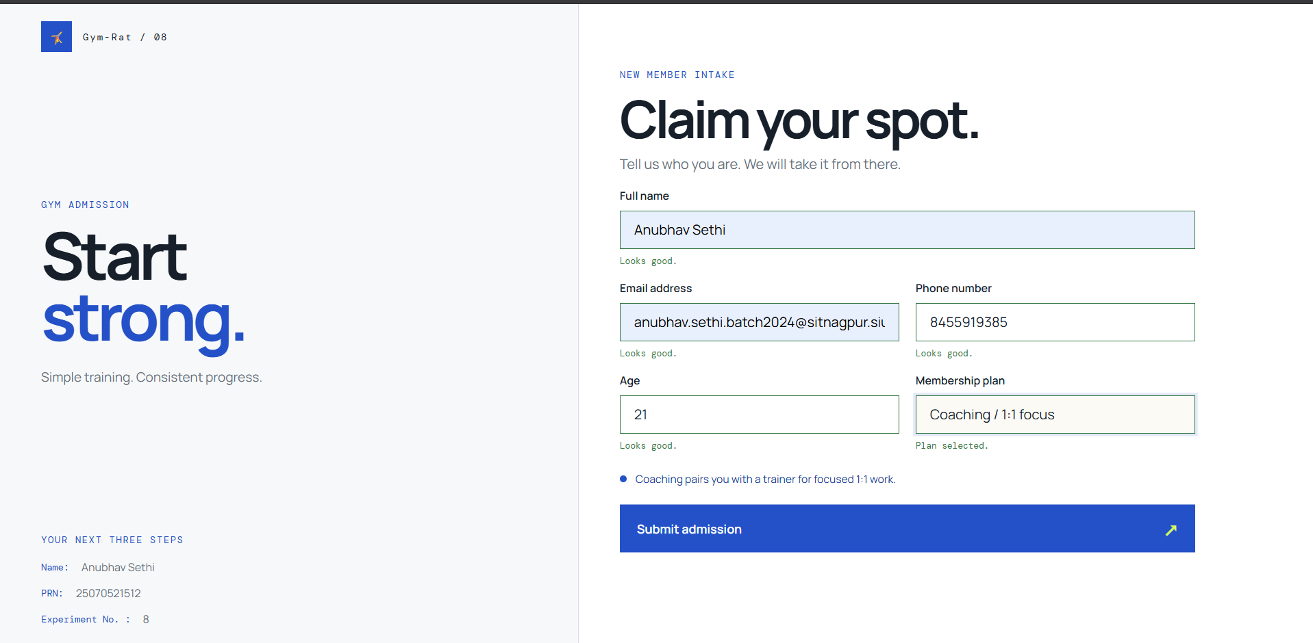
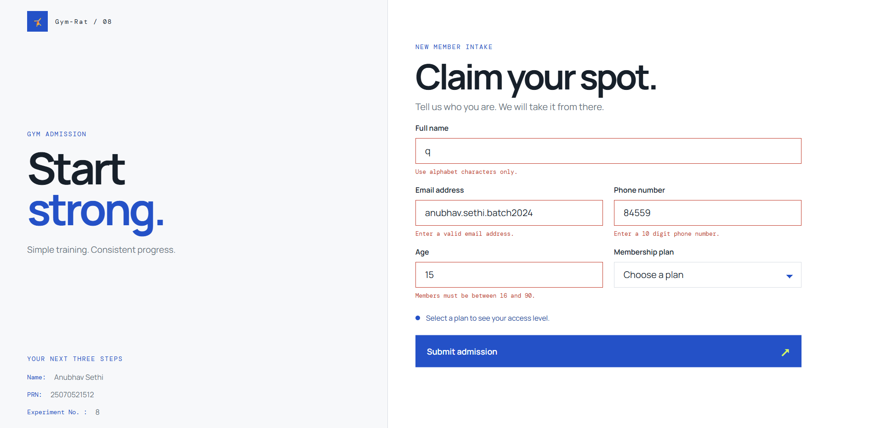


Result: Form fields were successfully accessed, monitored, and validated using JavaScript events and DOM manipulation.
Conclusion: Thus, JavaScript event handling and form validation provide an effective way to manage user input, detect errors, and maintain accurate form data.

